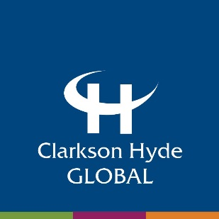

Standard wording for use in member promotional materials
Website (on your home page) / social media / business cards / other printed materials:

Wording for your website:
Clarkson Hyde Global logo with text underneath: Member firm of Clarkson Hyde Global. Global support with a local touch.
The above to either link directly to www.clarksonhydeglobal.com, or if preferred a dedicated website landing page with additional wording:

We are a member firm of Clarkson Hyde Global - a world-wide association of accountants, auditors, tax specialists and business advisors, working with small to medium-sized companies all over the world to help them achieve their goals.

When business owners want to reach out to new markets, customers and suppliers overseas, we can help with on the ground assistance on local laws, connections to appropriate business contacts and all of the financial, tax and regulatory assistance needed - providing a cost-effective alternative to the large advisory practices.
By working with Clarkson Hyde Global, you'll get first class, partner-led support from professionals who work together seamlessly to contribute to the smooth running of your business. What's more, our members are all self-employed in their own right and so understand the demands of operating and developing their own business.
Members of Clarkson Hyde Global are independent practices, which all meet strict professional criteria for accounting, auditing and tax standards set and closely monitored by the board. Not only this but they all share an ethos of providing positive and innovative advice and in gaining a commercial understanding of your business - essential to helping you reach the next level in the international arena.
If you would like to discuss your international business requirements, please contact YOUR PREFERRED CONTACT PERSON AND THEIR EMAIL / TELEPHONE.

Each member of the association is an independent accountancy / audit / tax firm which offers its own spectrum of services. Each member is responsible only for the services which it specifically provides.

Wording for use in social media profiles, alongside you / your firm's promotional text:

YOUR FIRM NAME is a member firm of Clarkson Hyde Global - a world-wide association of accountants, auditors, tax specialists and business advisors, working with small to medium-sized companies all over the world to help them achieve their goals.

When business owners want to reach out to new markets, customers and suppliers overseas, we can help with on the ground assistance on local laws, connections to appropriate business contacts and all of the financial, tax and regulatory assistance needed - providing a cost-effective alternative to the large advisory practices.
Visit www.clarksonhydeglobal.com for more information.
Email signature
Please see separate artwork you may wish to use a template for your email signature. If you are using your own template, please can you include the following two points of information in your email signature:
- Member firm of Clarkson Hyde Global (with either an imbedded link to the website: www.clarksonhydeglobal.com within the text or the web address stated separately for clients and contacts to click through)
- The Clarkson Hyde Global logo

